Old Geezers
-
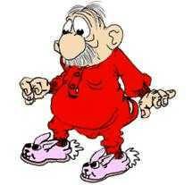
"Geezers" (slang for an old man) are easy to spot:
At sporting events, during the playing of
the National Anthem, Old Geezers hold
their caps over their hearts and sing without
embarrassment. They know the words and
believe in them.
Old Geezers remember
World War I, the Depression, World
War II, Pearl Harbor, Guadalcanal, Normandy
and Hitler. They remember the Atomic Age,
the Korean War, The Cold War, the Jet Age
and the Moon Landing, not to mention Vietnam.
If you bump into an Old Geezer on the sidewalk,
he will apologize. If you pass an Old Geezer
on the street, he will nod or tip his cap to a
lady. Old Geezers trust strangers and are
courtly to women. Old Geezers hold the door
for the next person and always, when walking,
make certain the lady is on the inside for protection.
Old Geezers get embarrassed if someone curses
in front of women and children and they don't like
any filth on TV or in movies. Old Geezers have
moral courage. They seldom brag unless it's
about their grandchildren.
It's the Old Geezers who know our great country
is protected, not by politicians or police, but by
the young men and women in the military serving their country.
This country needs Old Geezers with their decent
values. We need them now more than ever.
Thank God for Old Geezers!

